**E-Billing via Block Chain Technology**

**Prototypes**

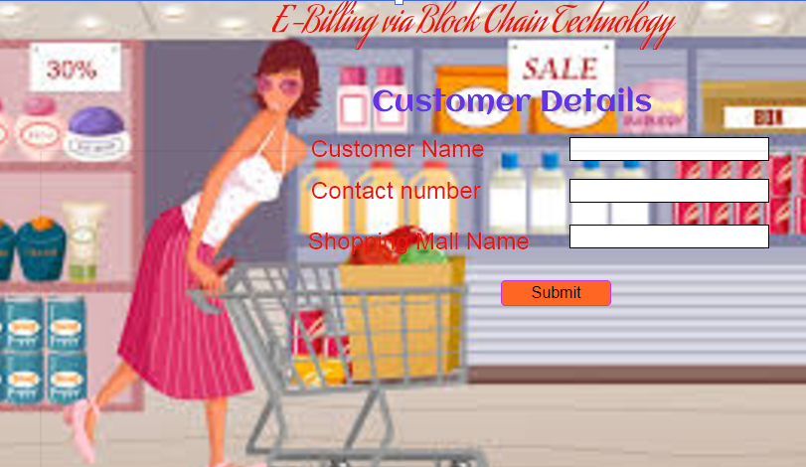

This prototype is the main home page of our website which takes customer details as input for further procedure.

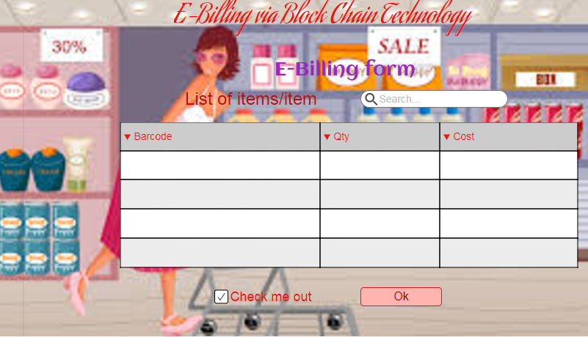

This prototype is the second page which is directed from the home page. In this page list of items in which the user is interested and their bar codes are scanned and entered by the user.

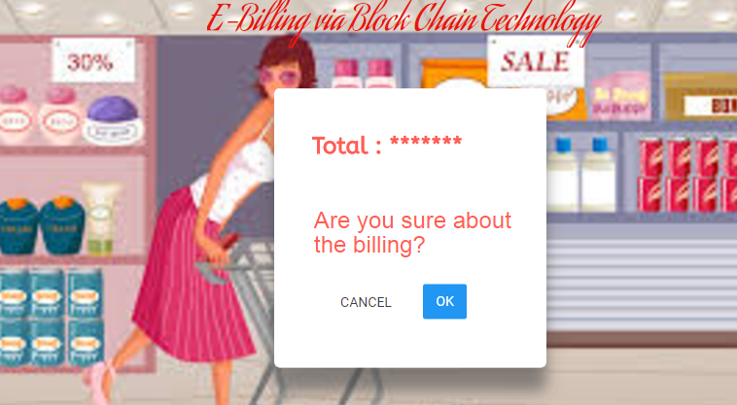

This prototype displays the result of the web page after the list of items are confirmed. In this web page the total is displayed and waits for the confirmation of the user for billing.

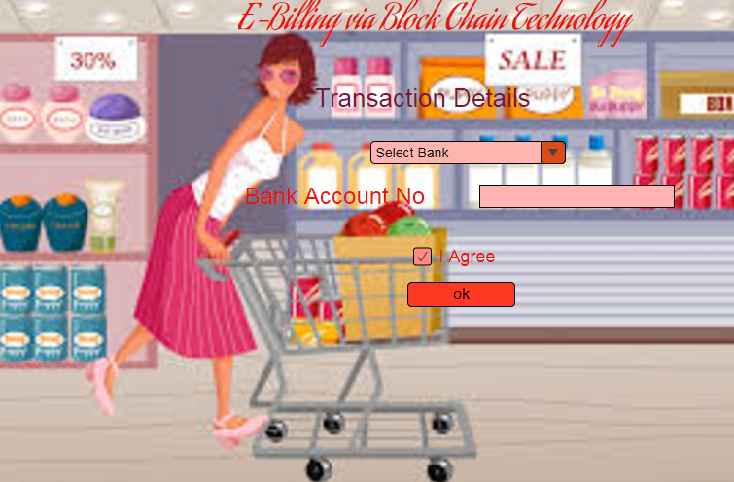

This prototype takes the name of the bank along with its details. After the user has agreed, further processing is done.

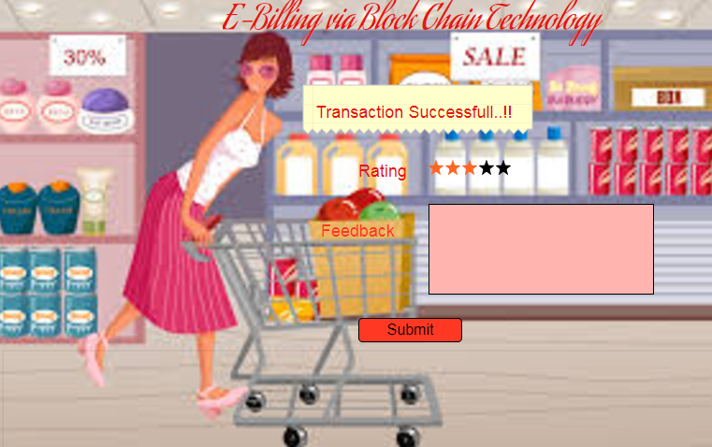

After completion of the transaction, message with content “TRANSACTION SUCCESSFULL” is displayed and further rating and feedback is taken from the user.